Taint a Node and Schedule a Tolerant Pod
Taint a node with special=true:NoSchedule.
Create a pod with a toleration that matches the taint, allowing it to be scheduled on the tainted node

Tainting the node with
Kubectl taint node worker01 special=true:NoShedule

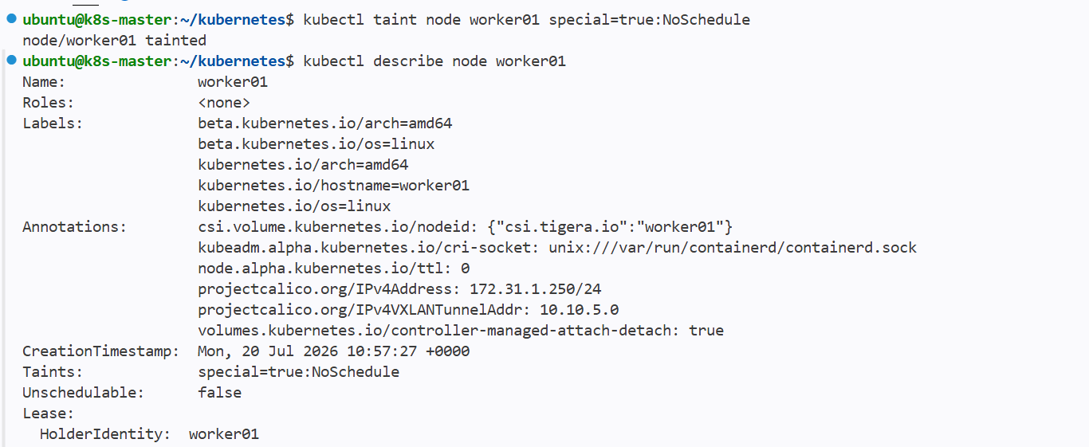

Creating the pod with tolerance equals to taint

So that pod will be sheduled on that node matches the tolerance

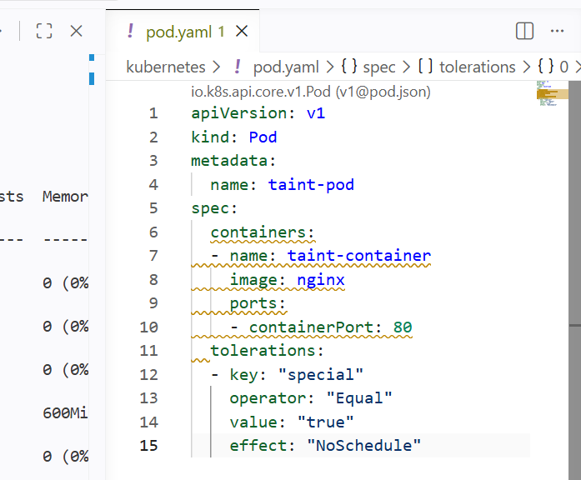

Restricted tolerations for pod so that it checks for the taints matched with the tolerations and assigns the pod to the node

But if another worker node accepts all nodes there is a chance that the pod can also be sheduled on the other node that accepts all nodes

======================================================================================================================================================

Use NodeSelector to Schedule a Pod on a Specific Node Label a node with env=dev. Create a pod with a nodeSelector that schedules it only on the node labeled env=dev

Nodeselector for pod assigns the pod to a node with matching labels

And nodeselector looks for the node that has same labels matched with the pod and then assigns the pod to the node
Giving the pod labels and env=dev and same labels will be adding to the node so that the pod assigns to the same node matching the selector

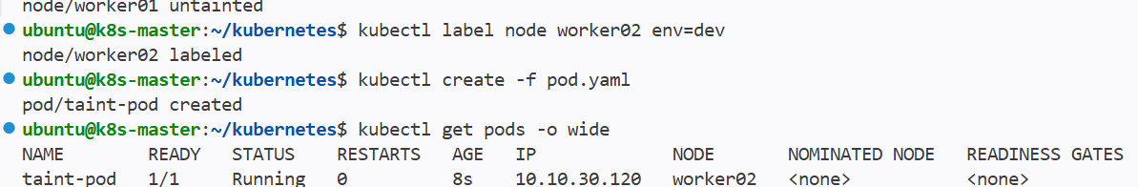

Attached a label to the worker node same as pod env=dev

Then the pod was created on the same worker node

We can also see the labels of worker02 same as pod labels

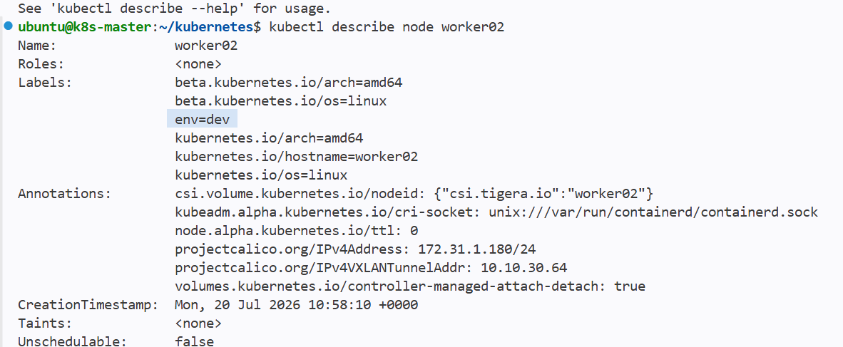

Label has been added to the node and nodeselector has selected the pod that has same label

======================================================================================================================================================

Use Node Affinity with Soft Scheduling
Label a node with env=test.
Create a pod with PreferredDuringSchedulingIgnoredDuringExecution node affinity, preferring to schedule it on a node labeled env=test. Remove the label and verify the pod continues to run

Step01:

Giving a nobe label with env=test
Using the Node Affinity for sheduling the pod on the node that matches the label
Using preferredduringshedulingignoredduringexecution is sheduler first checks for the same label if not matches then assigns to other node

First preference will be matching labels
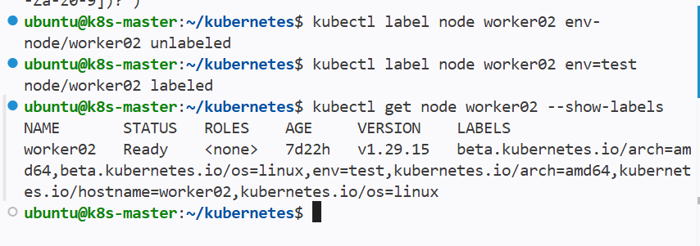

Removed the old labels and attached a new label fro node with env=test

And using nodeaffinity gave same label values

Now pod should be labelled on the worker02 node

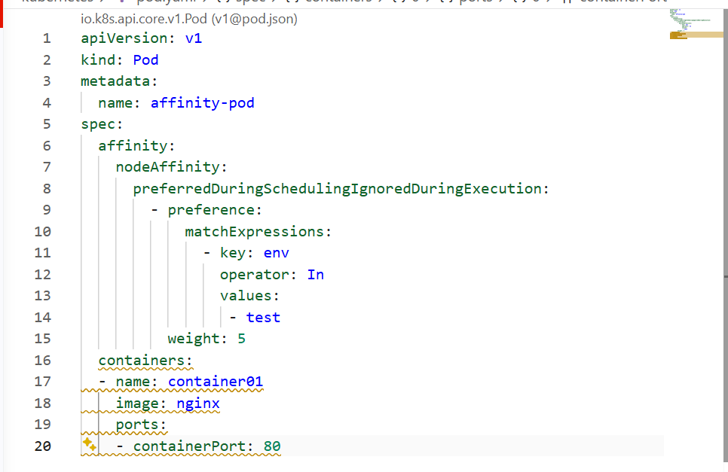

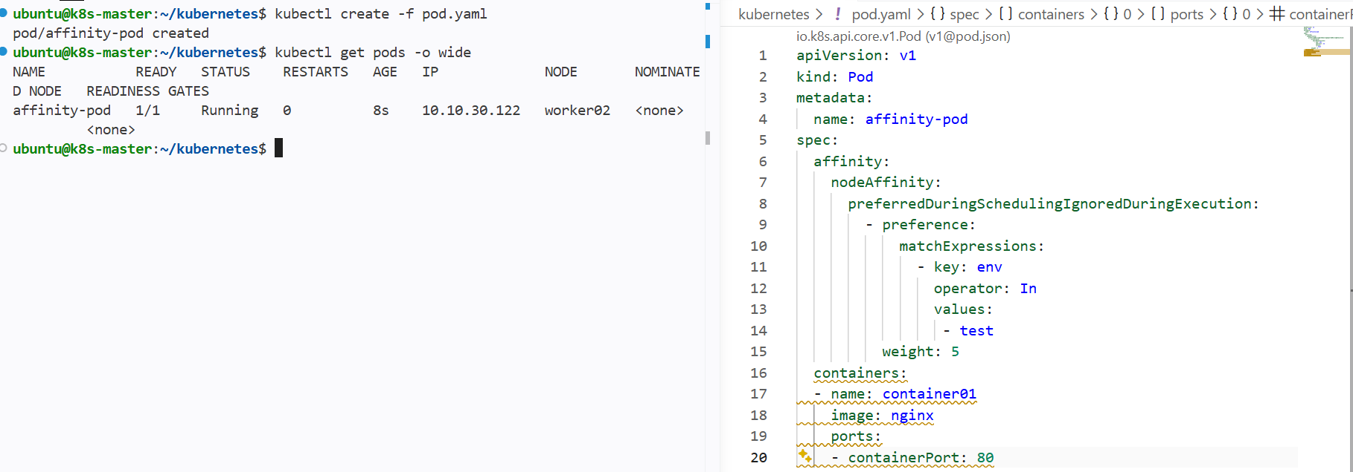

The pod has been sheduled on the worker02 node because off affinity

Even If the node doesn’t match any label then it will automatically shedules on othe available nodes

Now if I remove the label form the node still the sheduled pods will be in running and wont get terminated

Implement Node Affinity with Hard Scheduling
Create a pod with RequiredDuringSchedulingIgnoredDuringExecution node affinity, ensuring it will only be scheduled on a node labeled env=prod.
Verify the pod cannot be scheduled if no node has the env=prod label

Creating a pod with hardsheduling node affinity

Using the requireddurinshedulingignoredduringexecution

Now if the pod labels does nto match any node then the pod should not be sheduled on any node

It will only shedule in matched label of node

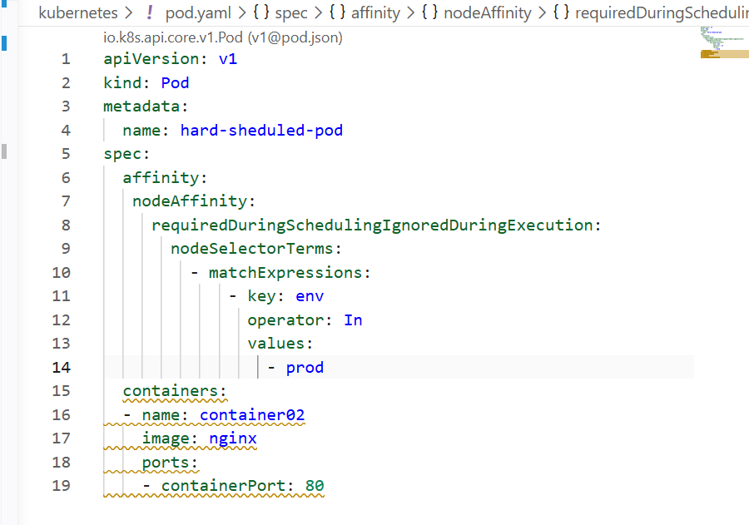

Used the hardsheduling techinique for sheduling the pods only if the label matches the pod for the node

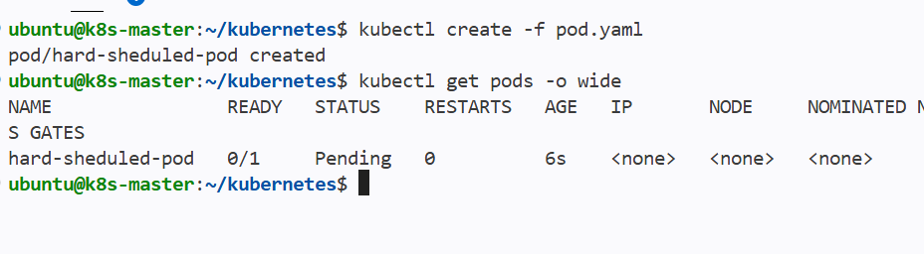

And pod has been created but the pod is still in pending state

And if we assign a label to the node then pod will be coming to the running state and assigned to the node that matches the label

Taint a Node and Use NoExecute with Toleration Seconds
Taint a node with special=true:NoExecute.
Create a pod with a tolerationSeconds field (e.g., 60 seconds) and observe it gets evicted after 60 seconds on the tainted node

NoExecute === id wont accept any pods in that particular nod and if any pods are already running on the node then it will delete the pods

Tainting a node with special=true:NoExecute

I have a pod running in my worker node now whenever I taint my node then it will termiante the running pods
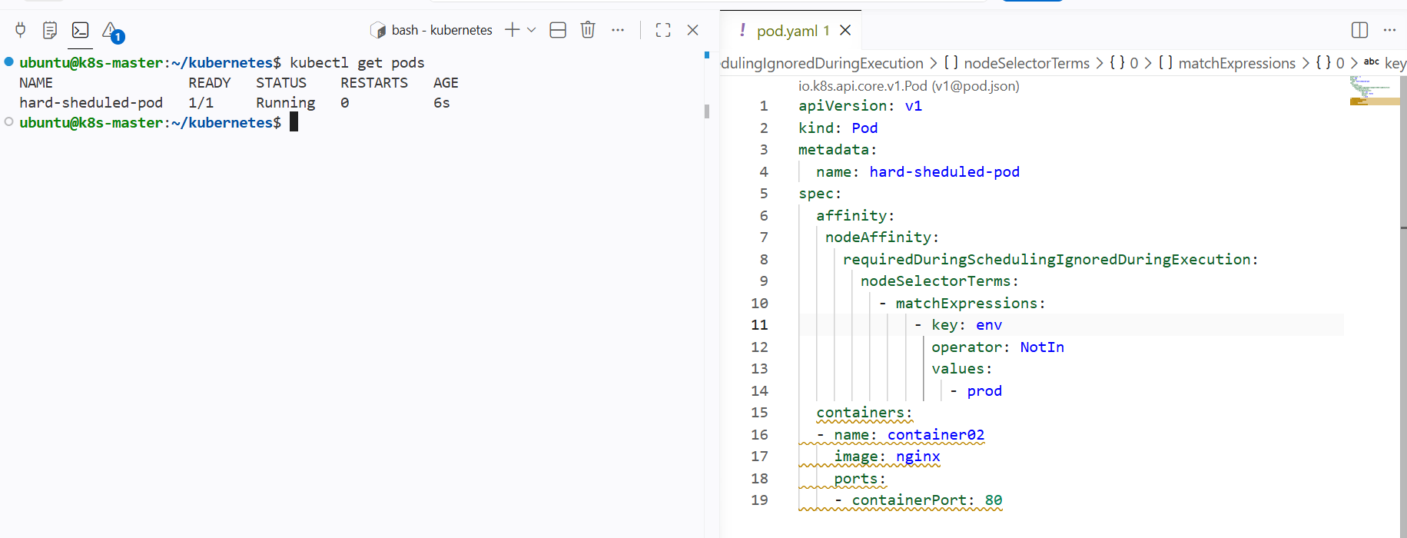

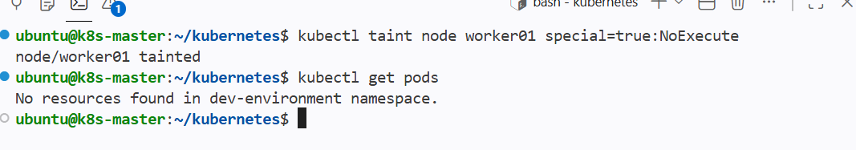

Now I have applied taint as noexecute then the pods running the node has been deleted

Now creating a pod then giving the toleration seconds for pod and then tainting the node and pod should be terminated after the given time

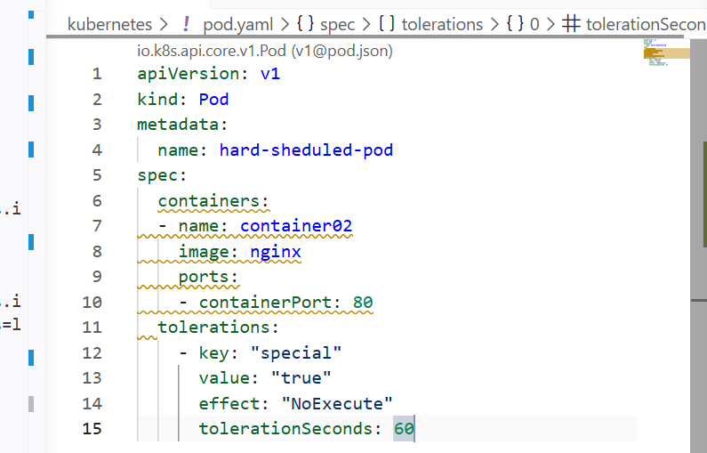

Adding the toleration seconds

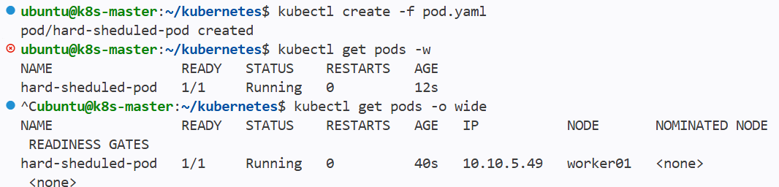

Pod has been created then we can see that after applyinng taint for the node then the pod is terminating after 60sec

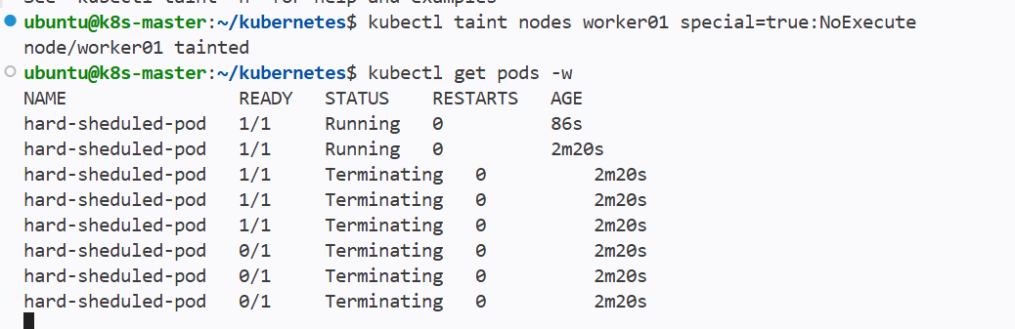

Even after tainting the node if we create a new pod then also the pod will be terminated after 60 sec



